# ***(Module-7) jQuery Basic, Effects & Advanced***

**Q1. What is jQuery?**

**Ans:** jQuery is a fast, small, and feature-rich JavaScript library. It simplifies things like HTML document traversal and manipulation, event handling, and animation. jQuery is designed to make it easier to navigate and manipulate the Document Object Model (DOM), which represents the structure of HTML and XML documents.

-> jQuery was particularly popular in the early days of web development when there were significant inconsistencies in how different browsers implemented JavaScript. While its usage has declined somewhat with the rise of modern JavaScript frameworks like React, Angular, and Vue.js.

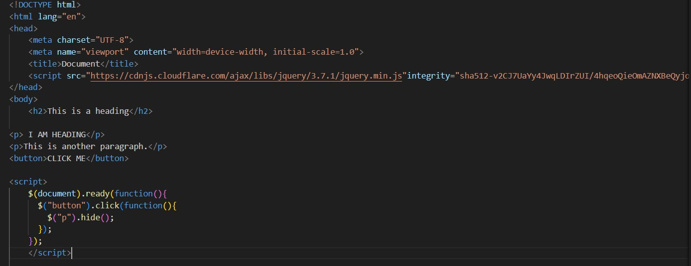

**Q2. How to Apply CSS Using JQuery, How to Add Class and Remove Class in jQuery, JQuery Animation?**

**Ans: Apply CSS Using JQuery:**

We can use jQuery to apply CSS styles to HTML elements dynamically. The “**css()”** method in jQuery allows you to get or set the CSS properties of elements.

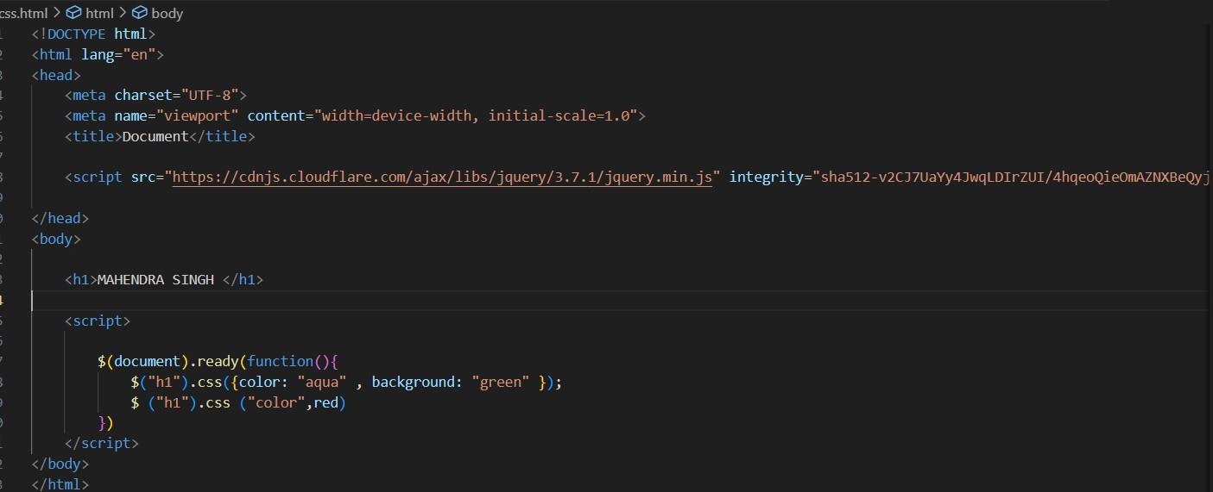

**Adding and Removing Classes using jQuery:**

-> jQuery provides methods to add and remove classes from HTML elements. These methods are “**addClass()”** and “**removeClass()”**.

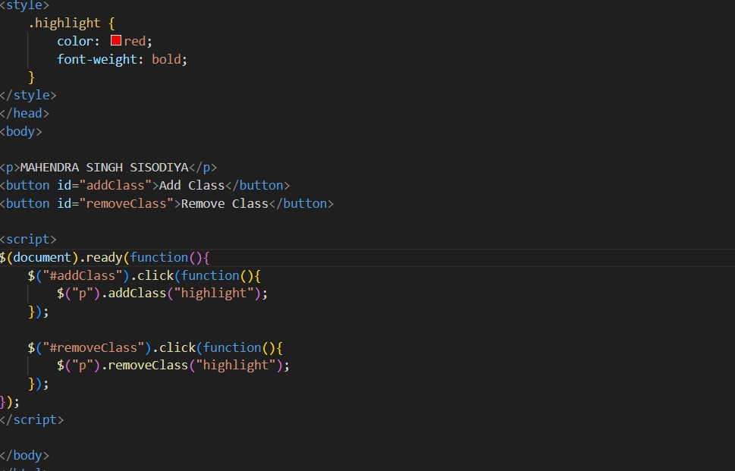

**jQuery Animation:**

-> jQuery provides built-in methods for simple animations. The “**animate()”** method is commonly used for this purpose. It allows you to animate CSS properties.

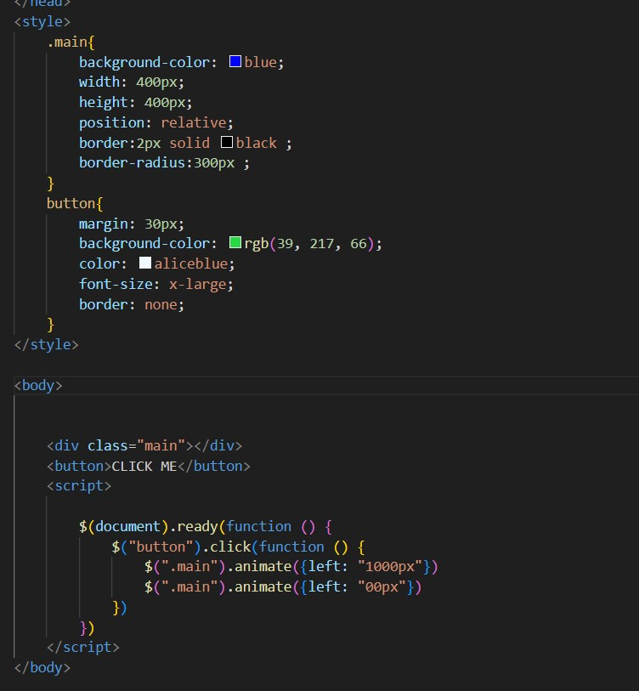

**Q3) How to create slider with animation?**

**Ans:** jQuery gives us functions for sliding images or divs or containers:

“slideDown()”, “slideUp()”, “slideToggle()”.

-> The jQuery slideUp() method is used to slide up an element.

The jQuery slideToggle() method toggles between the slideDown() and slideUp() methods.

